**DYNAMIC USAGE OF MACHINE LEARNING FOR EARLY DETECTION OF DIABETES**

### PROJECT WORK 1

**Submitted by**

**ABDUR RAHMAN BASIL A H 212223040002**

**BALA UMESH S 212221040024**

**ROHAN J 212223040171**

**KAMALESH 212222100019**

***in partial fulfillment for the award of the credits of***

## **THE COURSE**

***in***

### COMPUTER NETWORKS

**SAVEETHA ENGINEERING COLLEGE, THANDALAM**

**An Autonomous Institution Affiliated to**

## **ANNA UNIVERSITY - CHENNAI 600 025**

### APRIL 2024



**BONAFIDE CERTIFICATE**

**2023-2024**

Certified that this Computer Networks course project report, “DYNAMIC USAGE OF MACHINE LEARNING FOR EARLY DETECTION OF DIABETES” is the Bonafide work of ABDUR RAHMAN BASIL (212223040002), BALA UMESH (212221040024), ROHAN (212223040171), KAMALESH (212222100019), of 1st Year, 3rd year, 1st year, and 2nd year respectively of B.E Computer Science and Engineering, who carried out the Project Work of Computer Networks (19CS406) under my supervision and has not been submitted to any other coursework or University for the award of any degree by us.

|  |  |
| --- | --- |
| **SUPERVISOR**  Dr .G. Nalinipriya M.E.,Ph.D  Professor,  Department of Information Technology  Saveetha engineering college,  Thandalam,Chennai - 602105 |  |

**­**

**ABSTRACT**

Diabetica is a web-based tool designed to predict the likelihood of an individual having diabetes based on their health parameters. The platform utilizes machine learning algorithms to analyze input data such as cholesterol levels and other relevant health metrics. Unlike traditional methods, Diabetica provides a convenient and accessible way for users to assess their diabetes risk from the comfort of their homes.The website generates personalized predictions by training individualized machine learning models on a dataset containing relevant health information. By leveraging advanced algorithms, including logistic regression and data analysis techniques, Diabetica offers accurate predictions while considering the unique characteristics of each user.The findings from the study demonstrate the effectiveness of the website in predicting diabetes risk, providing users with valuable insights into their health. By utilizing the power of machine learning and web-based technologies, Diabetica empowers individuals to take proactive measures for their health and well-being.Diabetica leverages the Django web framework to provide a seamless user experience. Django's robust features, including its ORM for database management and built-in security measures, are instrumental in ensuring the reliability and efficiency of the platform. The website's frontend is developed using Django's templating system, allowing for dynamic content generation and a responsive user interface.Additionally, Django's authentication system is utilized to secure user data and ensure that only authorized individuals can access the platform. This ensures the privacy and confidentiality of users' health information. Furthermore, Django's admin interface is used for easy management of the website, enabling administrators to monitor user activity and manage data effectively.Overall, Django plays a crucial role in the development of Diabetica, providing a solid foundation for building a reliable, secure, and user-friendly web application for diabetes prediction.

Index terms: Machine learning, Diabetes prediction, Web-based application, Health parameters, Logistic regression, Data analysis

**ACKNOWLEDGEMENT**

I am indebted to our supervisor Dr. G. Nalinipriya , M.E.,Ph.D., for assisting us in the completion of my project with his exemplary Guidance and for her support during the entire course of this project.

**LIST OF ABBREVIATIONS**

* ML - Machine Learning
* HDL – High Density Lipoprotein
  + LR – Logistic Regression
  + BMI – Body Mass Index
  + RMSE - Root mean square error
  + MAE - Mean Absolute Error
  + HTML - Hypertext Markup Language
  + CSS - Cascading Style Sheets
  + Python - A high-level programming language

**TABLE OF CONTENTS**

|  |  |  |
| --- | --- | --- |
| **CHAPTER NO** | **TITLE** | **PAGE NO** |
| **1** | Introduction | 1 |
| **2** | Literature survey | 7 |
| **3** | System and software requirements | 9 |
| **4** | Proposed system Architecure and module | 9 |
| **4.1** | Methodology | 10 |
| **4.2** | System architecure | 11 |
| **4.3** | Module description | 12 |
| **5** | Imlementation | 12 |
| **5.1** | Performance analysis | 2 |
| **6** | Result and Discussion | 29 |
| **7** | Conclusion |  |

**1.INTRODUCTION**

Diabetes, a chronic metabolic disorder, has emerged as a significant global health concern, affecting millions of lives worldwide. The disease, characterized by elevated blood sugar levels, poses serious health risks and can lead to complications such as heart disease, stroke, and kidney failure. Managing diabetes requires regular monitoring of blood glucose levels, adherence to a healthy lifestyle, and sometimes, medication. Despite the advancements in medical science, the management of diabetes remains challenging, with many individuals struggling to effectively control their condition. The burden of diabetes is not only physical but also emotional and financial, impacting the quality of life of individuals and their families.

One of the key challenges in diabetes management is the early detection of the disease. Early diagnosis can enable individuals to make lifestyle changes and start treatment early, reducing the risk of complications. Current methods of diabetes screening can be invasive, time-consuming, and costly, limiting their accessibility and effectiveness.

In this context, the development of Diabetica, a web-based tool utilizing Django and logistic regression for diabetes prediction, holds immense promise. Diabetica aims to provide a user-friendly platform for individuals to assess their risk of diabetes based on key health parameters such as cholesterol levels. By leveraging the power of machine learning and web technologies, Diabetica seeks to empower individuals to take proactive steps towards managing their health and reducing the risk of complications associated with diabetes.

Through personalized predictions and actionable insights, Diabetica aims to revolutionize the way individuals approach diabetes management. By offering a convenient and accessible solution, Diabetica has the potential to significantly improve the lives of individuals affected by diabetes, enabling them to lead healthier and more fulfilling lives.

Diabetica's primary objective is to create a user-friendly platform that can accurately predict an individual's risk of diabetes based on their health parameters. By leveraging machine learning algorithms, such as logistic regression, Diabetica seeks to revolutionize the approach to diabetes management. The tool aims to empower individuals to make informed decisions about their health, leading to improved health outcomes and a better quality of life.

Through its innovative approach, Diabetica aims to address the challenges associated with diabetes management, offering a convenient and accessible solution for individuals to assess their risk of diabetes. By promoting early detection and proactive management of diabetes, Diabetica has the potential to make a significant impact on the lives of millions worldwide, offering hope for a healthier future.

Machine Learning (ML) has emerged as a transformative technology with the potential to revolutionize predictive modeling across various industries. ML algorithms, such as logistic regression, have gained prominence for their ability to analyze complex data sets and make accurate predictions. Logistic regression, in particular, is widely used for binary classification problems, making it invaluable for applications ranging from healthcare to finance.

Machine Learning algorithms, powered by vast amounts of data, can uncover patterns and insights that traditional statistical methods may overlook. This ability to learn from data and improve over time makes ML particularly effective for tasks such as predictive modeling, where the goal is to make accurate predictions based on historical data.

Logistic regression is a type of regression analysis used for predicting the outcome of a categorical dependent variable based on one or more independent variables. Unlike linear regression, which is used for continuous variables, logistic regression is ideal for binary outcomes, making it suitable for a wide range of applications, including customer churn prediction, spam detection, and medical diagnosis.

The combination of ML and logistic regression holds immense promise for revolutionizing predictive modeling. By leveraging the power of these technologies, organizations can make more accurate predictions, optimize processes, and make informed decisions based on data-driven insights.

In conclusion, Machine Learning and logistic regression represent a powerful combination that is transforming predictive modeling. As these technologies continue to evolve, their impact on various industries is expected to grow, ushering in a new era of data-driven decision-making and innovation.

Top of Form

Traditionally, diabetes prediction and management have relied on conventional methods that involve regular monitoring of blood glucose levels, dietary control, physical activity, and medication. Healthcare providers typically use a combination of tests, including fasting blood sugar tests, oral glucose tolerance tests, and glycated hemoglobin (HbA1c) tests, to diagnose diabetes and assess its severity.

Treatment for diabetes usually involves a combination of lifestyle changes and medication. Diet plays a crucial role in managing diabetes, with individuals advised to consume a balanced diet rich in fruits, vegetables, whole grains, and lean proteins while limiting sugar, saturated fats, and processed foods. Regular physical activity is also recommended to help control blood sugar levels and maintain overall health.

In addition to lifestyle modifications, medication is often prescribed to manage diabetes. Common medications include insulin, which helps regulate blood sugar levels, and oral medications such as metformin, sulfonylureas, and DPP-4 inhibitors, which help improve insulin sensitivity and reduce blood sugar levels.

Despite these traditional methods, diabetes management remains challenging, with many individuals struggling to achieve optimal blood sugar control. Factors such as diet, physical activity, stress, and medication adherence can impact blood sugar levels, requiring constant monitoring and adjustment of treatment plans.

Furthermore, the traditional approach to diabetes management may not always be effective in preventing complications associated with the disease. Complications such as heart disease, stroke, kidney failure, and nerve damage can occur if blood sugar levels are not properly controlled over time.

In light of these challenges, there is a growing need for innovative solutions that can enhance the prediction and management of diabetes. Diabetica aims to address these needs by providing a user-friendly platform that leverages machine learning and web technologies to predict an individual's risk of developing diabetes and provide personalized recommendations for management.

Machine learning techniques play a crucial role in predicting diabetes risk and improving the management of the disease. Here are some key machine learning techniques used in diabetic prediction:

1. **Logistic Regression:** Logistic regression is a commonly used technique for binary classification tasks, such as predicting whether a patient has diabetes or not based on various features. It models the probability of the presence of a condition by fitting data to a logistic curve.
2. **Random Forest:** Random forest is an ensemble learning method that uses multiple decision trees to improve prediction accuracy. It can handle large datasets with high dimensionality and is effective in capturing complex relationships between features.
3. **Support Vector Machines (SVM):** SVM is a supervised learning algorithm that can be used for classification and regression tasks. It works by finding the hyperplane that best separates the classes in the feature space, maximizing the margin between the classes.
4. **Neural Networks:** Neural networks, especially deep learning models like convolutional neural networks (CNNs) and recurrent neural networks (RNNs), have shown promise in diabetic prediction. They can learn complex patterns from data and are particularly effective in processing sequential data, such as time-series data from glucose monitoring devices.
5. **Gradient Boosting Machines:** Gradient boosting machines (GBM) are another ensemble learning method that combines multiple weak learners to create a strong learner. GBM iteratively improves the model by minimizing a loss function, making it suitable for handling imbalanced datasets and achieving high predictive accuracy.
6. **K-Nearest Neighbours (KNN):** KNN is a simple and intuitive machine learning algorithm that classifies new data points based on the majority class of their nearest neighbours. It is effective for small to medium-sized datasets and can be used for both classification and regression tasks.

These machine learning techniques, when applied to datasets containing relevant features such as glucose levels, cholesterol levels, BMI, and other health parameters, can help predict the risk of diabetes and provide valuable insights for disease management.

Diabetes represents a significant and growing global health challenge, affecting millions of individuals and imposing substantial burdens on healthcare systems worldwide. The condition, characterized by high blood sugar levels, can lead to serious complications such as heart disease, stroke, kidney failure, and nerve damage if not managed effectively. Early prediction of diabetes is essential for implementing timely interventions, lifestyle modifications, and medical treatments to prevent or delay the onset of complications and improve quality of life.

Traditional methods for diabetes prediction and management have relied on regular monitoring of blood glucose levels, dietary control, physical activity, and medication. While these approaches are effective to some extent, they are often limited by their reliance on manual measurements and subjective assessments, which can be time-consuming, costly, and prone to human error.

In recent years, machine learning (ML) techniques have emerged as powerful tools for diabetes prediction, offering the potential to enhance traditional methods and provide more accurate and personalized predictions. ML algorithms can analyze large amounts of data, including electronic health records, genetic information, and lifestyle factors, to identify patterns and predict future outcomes. By leveraging these algorithms, healthcare providers can develop more effective strategies for diabetes management, including personalized treatment plans and interventions.

A systematic review of the current state of research on ML for diabetes prediction reveals a wide range of approaches and techniques being used. Logistic regression, random forest, support vector machines, neural networks, and gradient boosting machines are among the ML techniques commonly employed for diabetes prediction. These techniques have shown promise in improving prediction accuracy and providing valuable insights into the underlying mechanisms of the disease.

Despite the potential benefits of ML in diabetes prediction, several challenges remain. One of the main challenges is the need for large and diverse datasets to train ML models effectively. Additionally, the interpretability of complex ML models can be a significant barrier to their adoption in clinical practice, as healthcare providers may be hesitant to trust predictions that they cannot easily understand or explain.

Moving forward, future research should focus on addressing these challenges and further exploring the potential of ML in diabetes prediction and management. By developing more accurate and interpretable ML models, healthcare providers can improve the early detection of diabetes, personalize treatment plans, and ultimately improve outcomes for individuals living with this chronic condition.

Top of Form

The complexity of diabetes and its multifactorial nature pose challenges for prediction. ML offers a means to analyze vast datasets, identifying patterns and making predictions. Several ML algorithms have been applied, including logistic regression, decision trees, random forests, support vector machines, and neural networks.

Logistic regression, commonly used for binary classification tasks, predicts diabetes based on features like age, body mass index (BMI), and blood pressure. Decision trees are versatile, handling categorical and numerical data, making them suitable for diabetes prediction. Random forests, a collection of decision trees, enhance prediction accuracy by reducing overfitting.

Support vector machines (SVMs) are supervised learning algorithms useful for both classification and regression. SVMs identify the hyperplane that best separates classes in the feature space, aiding in diabetes risk prediction. Neural networks, particularly deep learning models, excel at capturing intricate patterns in diabetes data, resulting in improved prediction accuracy.

In conclusion, ML techniques offer promise in revolutionizing diabetes prediction, providing more accurate and personalized risk assessments. However, challenges remain, such as the need for larger and more diverse datasets and the interpretability of complex ML models. Future research should focus on overcoming these challenges and exploring ML's full potential in diabetes prediction and management.

Classification is a fundamental procedure in data mining and machine learning, where data is categorized into distinct classes and assigned labels accordingly. Prediction models, on the other hand, predict continuous valued functions. Both classification and prediction are essential techniques for effectively diagnosing various problems using data mining and machine learning techniques.

Classification is particularly significant in disease prediction, including diabetes. It is one of the most common data mining tasks, as large amounts of business and medical datasets often require classification. The goal of classification is to allocate items in a collection to target categories, achieving high accuracy in classifying datasets related to diabetes patients.

Various machine learning algorithms are used for classification, such as J48, SVM, Naive Bayes, Decision Tree, Logistic Regression, and Artificial Neural Networks (ANN). These algorithms are effective in diagnosing different diseases, including diabetes.

In the proposed work, the key objective is to classify data as diabetic or non-diabetic and improve classification accuracy using machine-learning algorithms. Supervised classification algorithms like SVM, Discriminant Analysis, Naive Bayes, K-nearest Neighbor, and Regression, as well as unsupervised clustering techniques, are used.

In many real-world problems, classification is a significant decision-making technique. However, in classification problems, increasing the amount of samples chosen does not necessarily lead to higher classification accuracy. While algorithm performance may be high in terms of speed, the accuracy of data classification can be low.

The main objective of the model is to achieve high accuracy in diabetes prediction. This can be achieved by using a large portion of the dataset for training and a smaller portion for testing. Various classification techniques are analyzed for the classification of diabetic and non-diabetic data, focusing on early prediction to avoid diabetes complications and maintain health.

Classification applications extend to various fields such as speech recognition, handwriting recognition, biometric identification, document classification, spam filtering, sentiment analysis, biological classification, pattern recognition, and credit scoring. These applications demonstrate the versatility and importance of classification techniques in diverse domains.

**2. LITERATURE SURVEY**

G. Parimala et al, in their study used Naive Bayes Classification is employed. Naive Bayes is a widely used algorithm for classification tasks, especially in text classification, due to its simplicity and efficiency. It operates based on Bayes theorem, which calculates the probability of a hypothesis given the data. Diabetes prediction models utilize features such as glucose level, body mass index (BMI), age, insulin level, and external characteristics associated with diabetes (e.g., family history, diet, exercise habits), along with other standard components. These features collectively help in assessing the risk of developing diabetes. The model's strength lies in its inclusion of critical features like glucose level, BMI, age, and insulin level, which are known to be significant in diabetes prediction, thus enhancing its accuracy. However, the model's reliance solely on these features might limit its predictive capability by potentially overlooking other relevant factors not present in the dataset.

Md. Faisal et al, in their paper "Early Prediction of Diabetes Mellitus using Machine Learning Techniques," explore the application of four popular machine learning algorithms: Support Vector Machine (SVM), Naive Bayes (NB), K-Nearest Neighbor (KNN), and C4.5 decision tree. Their study focuses on utilizing a dataset comprising 16 attributes related to diabetes mellitus, including factors such as age, diet, hypertension, vision problems, and genetic factors. This project is situated within the domains of healthcare, particularly diabetes management and early prediction, as well as machine learning and data mining for medical applications. The research highlights the high prediction accuracy achieved, particularly with the C4.5 decision tree algorithm, emphasizing the importance of input feature quality and relevance in such predictive modeling efforts.

Nahla Barakat et al employed a range of machine learning techniques, including algorithms, feature engineering, data processing, and model evaluation, in their study. The features considered in their research encompassed age, gender, BMI, glucose level, blood pressure, skin thickness, insulin level, family history, pregnancy status, physical activity, diet, and cholesterol levels. The study's focus was on using machine learning predictive models to identify students at risk of stress early on. However, the researchers noted the potential risk of bias in predictions based on historical data, emphasizing the need for continuous monitoring and adjustments to mitigate such biases.

Roshi Saxena et al utilize supervised machine learning algorithms like logistic regression, SVM, decision trees, random forest, and ensemble methods to predict diabetes based on health-related attributes. Their study involves datasets containing glucose levels, BMI, and blood pressure to determine the likelihood of diabetes. Features such as age, BMI, glucose levels, insulin levels, blood pressure, and other health-related attributes are used to train machine learning models for predicting diabetes. While these models offer early detection and personalized treatment options, challenges include acquiring and processing large, high-quality datasets for training, and the need for specialized expertise to interpret results in medical contexts, which may raise ethical and privacy concerns.

Md. Maniruzzaman et al in thier study aims to develop a machine learning (ML)-based system for predicting diabetic patients, given the rising prevalence of diabetes and its associated complications. Logistic regression (LR) was used to identify significant risk factors for diabetes, with seven factors including age, education, BMI, systolic BP, diastolic BP, direct cholesterol, and total cholesterol found to be significant. Four classifiers (naïve Bayes, decision tree, Adaboost, and random forest) were then used to predict diabetic patients, with the LR-based feature selection and random forest-based classifier combination showing the highest accuracy of 94.25% and an AUC of 0.95 for the K10 protocol. The study concludes that the combination of LR and random forest-based classifiers performs well and can be useful in predicting diabetic patients.

Parastoo Rahimloo et al int thier paper introduces a method for accurate diabetes prediction by combining neural networks and logistic regression. It first presents the parameters for laboratory testing and their impact on diabetes prediction. Logistic regression is used to determine the impact of each parameter on the output, leading to the proposed model for accurate prediction. The results show that the combination of neural networks and logistic regression reduces errors in predicting diabetes, allowing for early detection and necessary actions. The study concludes that this combined approach is effective in predicting diabetes.

Ms.B.Sujani Reddy et al in thier methodology involves data collection from various sources, data preprocessing to clean and normalize the data, feature selection to identify important elements, model training using logistic regression, model evaluation using metrics like accuracy and ROC-AUC score, hyperparameter tuning for optimization, validation using techniques like cross-validation, and interpretation of the model coefficients. The flowchart depicts the process from entering parameter values on the website to viewing the predicted outcome for diabetes. The conclusion highlights the benefits of using logistic regression for diabetes detection, including simplicity and interpretability, while acknowledging its limitations and suggesting areas for future research to enhance its capabilities. The author acknowledges CMR College of Engineering & Technology for providing facilities and support.

**3. SYSTEM AND SOFTWARE REQUIREMENTS**

The system requires a modern desktop or laptop computer, with at least an Intel Core i3 processor or equivalent. It should have a minimum of 4GB of RAM, although more is recommended for handling larger datasets. Sufficient storage space, typically a few gigabytes, is necessary to store the dataset and the model. The system is compatible with major operating systems such as Windows, macOS, and Linux.

For software requirements, the system relies on Python as the core programming language. It also requires the Django framework for web application development, and HTML/CSS for designing the user interface. Additionally, libraries like Pandas, NumPy, Matplotlib, and Scikit-learn are essential for data manipulation, analysis, and visualization.

**Top of Form**

**4. PROPOSED SYSTEM ARCHITECURE AND MODULE**

The proposed system, Diabetica, consists of several main components:

1. **Scrape the Dataset Using Python:** The process involves acquiring a dataset relevant to diabetes prediction, including data on cholesterol levels, glucose levels, BMI, age, and other health indicators. Python data science libraries like Pandas, NumPy, and Scikit-Learn within Google Colab are used for developing machine learning models, facilitating dataset exploration, preprocessing, and analysis.
2. **Data Processing:** The dataset undergoes preprocessing steps before model training. This includes cleaning the data by changing all commas to periods for numeric values, encoding the target variable into binary format, retaining non-null values, and removing unnecessary columns to streamline the dataset for training.
3. **Performance Metrics:** Critical performance metrics include the root mean square error (RMSE), Mean Absolute Error (MAE), R-squared (R2), Pearson correlation coefficient, accuracy, and confusion matrix. These metrics help evaluate the model's performance in predicting stress levels accurately.

The scope of the Diabetica project is to develop a web-based application that utilizes a simple logistic regression model to predict whether an individual has diabetes. The primary goal is to provide users with an easy-to-use interface to input their health data and receive an accurate prediction of their diabetes status. The application aims to be user-friendly, with features such as data validation, result visualization, and user notification. Data privacy and security measures will be in place to protect user information. Integration with wearables, personalized recommendations, and advanced analytics are considered for future enhancements.

Overall, Diabetica aims to provide users with a valuable tool for predicting their diabetes risk and empowering them to make informed decisions about their health.

**4.1 METHODOLOGY**

The methodology of Diabetica follows a systematic flow chart, starting with user input of health data. The data then undergoes preprocessing, where it is cleaned, encoded, and prepared for analysis. Next, the preprocessed data is fed into a logistic regression model for predicting diabetes status. Once the model makes its predictions, a report is generated summarizing the results. Finally, the output, which indicates whether an individual is diabetic or not, is presented to the user in a clear and understandable format. This structured approach ensures that the prediction process is efficient, accurate, and user-friendly.

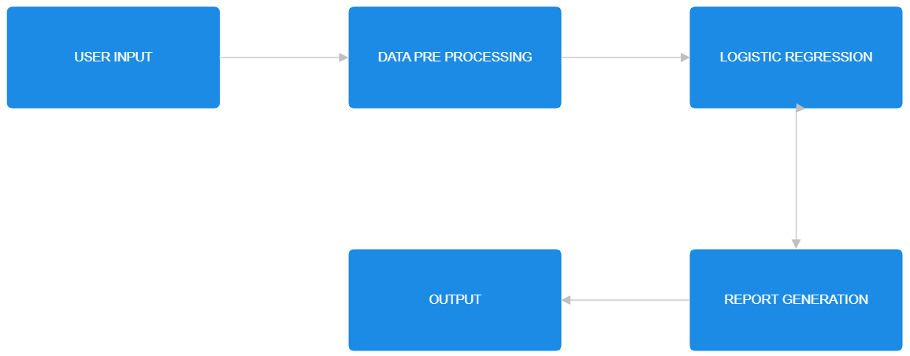

Fig. 3.1 Flow Diagram

**4.2 SYSTEM ARCHITECUTRE**

The architecture of Diabetica is designed to be a web-based application, making it accessible to users through their browsers. The system architecture follows a client-server model, where the client, typically a web browser, interacts with the server hosting the Diabetica application.

On the client side, users interact with the application through a user-friendly interface. This interface allows users to input their health data, such as glucose levels, cholesterol levels, BMI, and other relevant indicators. The input data is then sent to the server for processing.

The server side of the architecture is responsible for handling the data processing and prediction tasks. Upon receiving the user's input, the server preprocesses the data, which includes cleaning, encoding, and preparing it for analysis. The preprocessed data is then fed into a logistic regression model, which predicts the likelihood of the user having diabetes based on the input features.

Once the prediction is made, the server generates a report summarizing the results. This report includes the predicted diabetes status, along with any additional insights or recommendations based on the input data. Finally, the server sends the report back to the client, where it is presented to the user in a clear and understandable format.

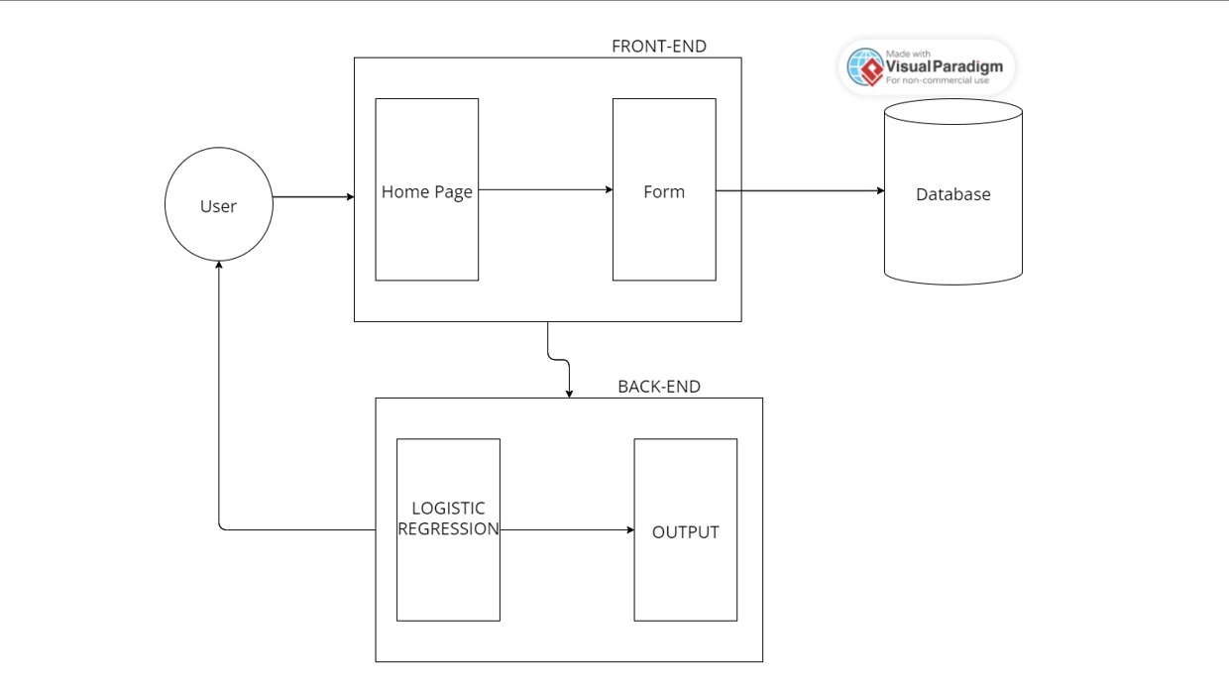

Fig.3.2 Architecure Diagram

**4.3 MODULE DESCRIPTION**

The Diabetica project consists of several main components, including data scraping using Python, data processing, training and evaluation of ML models.

In the data scraping module, datasets relevant to diabetes prediction are acquired from external sources, encompassing various health indicators such as cholesterol levels, glucose levels, BMI, and age. Python libraries like Pandas, NumPy, and Scikit-Learn are leveraged within Google Colab to explore, preprocess, and analyze these datasets efficiently.

Subsequently, the data processing module involves cleaning the datasets by standardizing numeric values and encoding categorical variables. The target variable is prepared for binary classification, and the dataset is streamlined for model training.

The training and evaluation module focuses on loading the dataset into a Pandas DataFrame for manipulation and selecting relevant input features for modeling. Imputation techniques are applied to address missing values, and categorical data is encoded for machine learning. The DataFrame is then split into training and testing sets using a random train-test split stratified by target classes, ensuring a balanced distribution for model training and evaluation.

This comprehensive approach enables the creation and assessment of data-driven models for predicting diabetes effectively.

**Top of Form**

**5. IMPLEMENTATION**

In the implementation of the Diabetica project, the Django development server is hosted to serve the web application. Upon accessing the server, users are directed to the home page where they are presented with a "Get Started" button. Clicking on this button navigates users to a new page where they are presented with two options:

1. Demo Button: Clicking on the "Demo" button triggers the application to randomly select a set of values from the Diabetes.csv dataset. The selected values are then used as input for the logistic regression model. The model predicts whether the individual has diabetes or not based on the input values, and the output is displayed to the user.
2. User Input Button: Clicking on the "User Input" button allows the user to input their own values for cholesterol level, glucose level, HDL cholesterol level, age, gender, height, weight, systolic blood pressure, diastolic blood pressure, waist circumference, and hip circumference. Once the user inputs these values and submits them, the application performs logistic regression on the user-provided data to predict whether the individual has diabetes or not. The prediction output is then displayed to the user.

This implementation allows users to interact with the Diabetica web application, providing them with the ability to explore diabetes prediction using logistic regression both with demo data and their own input values.

**5.1 PERFORMANCE MEASURES**

In the Diabetica project, the Logistic Regression (LR) model is trained and evaluated using the dataset to predict diabetes. Logistic Regression is a linear model commonly used for binary classification tasks, making it suitable for predicting whether an individual has diabetes or not based on the input features.

The performance of the Logistic Regression model is assessed using the classification_report function from the sklearn.metrics module. This function provides metrics such as precision, recall, F1-score, and support for each class (diabetes and no diabetes), helping to evaluate the model's accuracy and effectiveness in classifying individuals.

The LR model is trained using the input features and target variable from the dataset. The dataset is preprocessed to handle missing values, encode categorical variables, and prepare the data for training. After training, the model is tested using a separate test set to evaluate its performance on unseen data.

The output of the LR model is used to predict whether an individual has diabetes or not. This prediction can be used to provide valuable insights for healthcare professionals and individuals to make informed decisions about diabetes management and prevention.

**6. RESULT AND DISCUSSION**

In the project "Diabetica: Dynamic Usage of Machine Learning for Early Detection of Diabetes," we aimed to develop a robust predictive model for early detection of diabetes using machine learning techniques. The project's results provide valuable insights into diabetes prediction and proactive healthcare management. Leveraging machine learning methodologies, our project successfully developed a predictive model capable of categorizing individuals' likelihood of having diabetes. Through meticulous data collection and preprocessing, including tasks such as data cleaning, normalization, and feature extraction, our model was trained and evaluated on a comprehensive dataset to ensure its reliability and effectiveness in predicting diabetes. Evaluation metrics played a crucial role in assessing the performance of our diabetes prediction model. Metrics such as accuracy, precision, recall, and F1-score provided quantitative measures of the model's effectiveness in predicting diabetes. Analyzing the model's performance across these metrics helped us understand its strengths and limitations, enabling us to make informed decisions and refine the model further. Furthermore, feature importance analysis helped us identify the most influential variables in predicting diabetes. This analysis provided valuable insights into the key predictors or indicators of diabetes, enhancing the interpretability of our model and informing personalized healthcare strategies. The visualization of predicted diabetes outcomes further enriched our project's outcomes, providing stakeholders with intuitive insights into diabetes trends and patterns. Visual representations of diabetes predictions over time or across different demographic groups helped us identify critical trends and anomalies, guiding proactive healthcare interventions. The user interface and deployment aspect of our project ensured accessibility and usability for end-users. A user-friendly interface facilitated diabetes prediction and visualization of results, empowering individuals to monitor and manage their health effectively. Through validation testing and user feedback, we iteratively refined the user interface and model functionalities, ensuring alignment with user needs and preferences.

**HOME PAGE:**

The home page is designed using html and bootstrap, it has a “Get started” button which navigates to the next page. It also has links to contact and read the descrption.

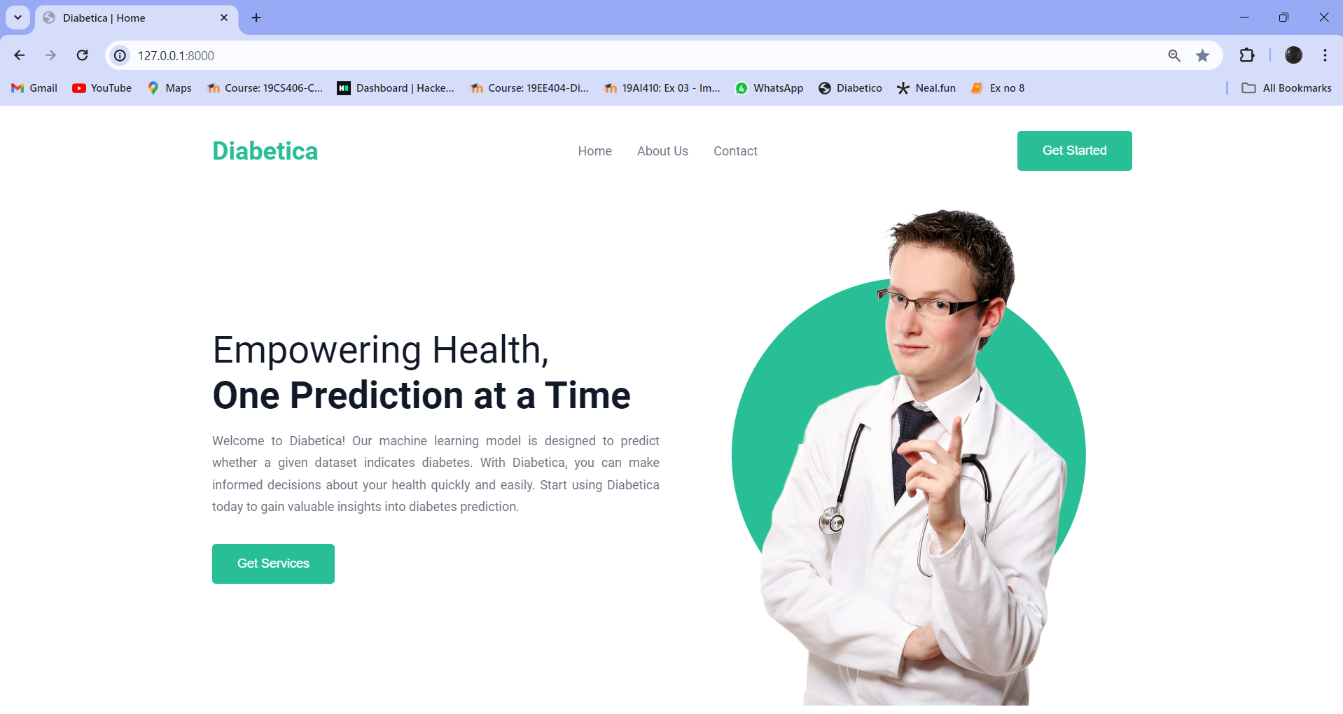

**Fig 5.1 Home Page of Diabetcia**

**INPUT FOR CHOICES:**

The main purpose of this page is to switch modes between a demo and the user input. On clicking the demo, the app will automatically choose a value from the dataset and demonstrate a sample of this project. On choosing the user input mode, a form will appear and user can input their own values and get the prediction for those data’s.

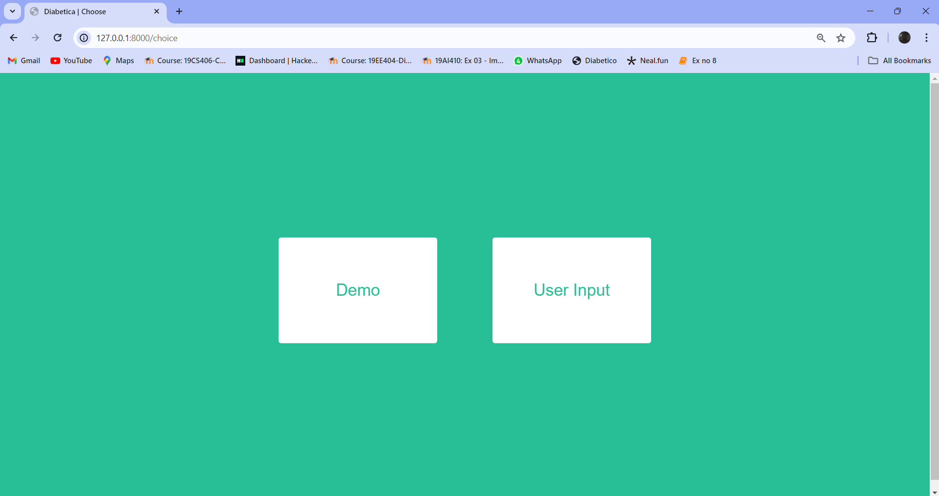

**Fig 5.2 input for choices**

**REPORT PAGES:**

The report page displays the report whether the patient has diabetes or not, apart from that it shows additional results of what levels are not ideal.

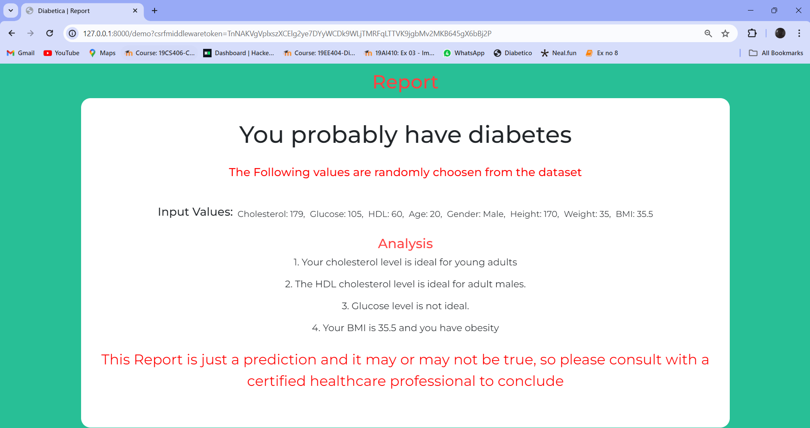

**Fig 5.3 Report of Demo page**

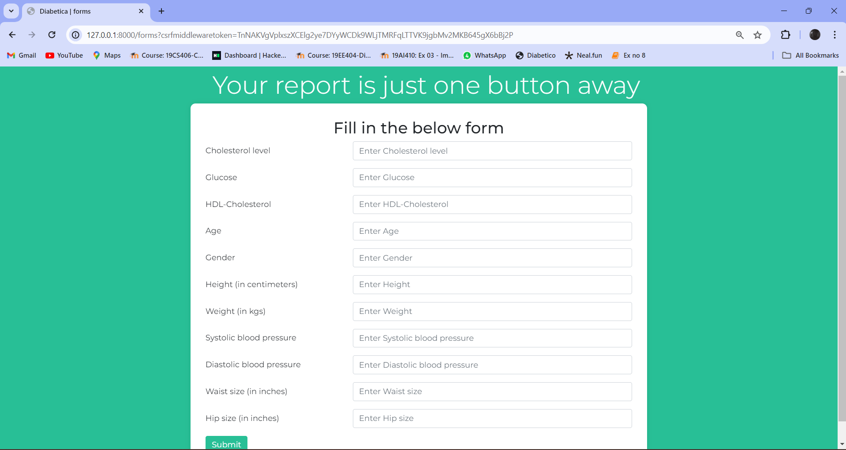

**Fig 5.4 User Details Input Form**

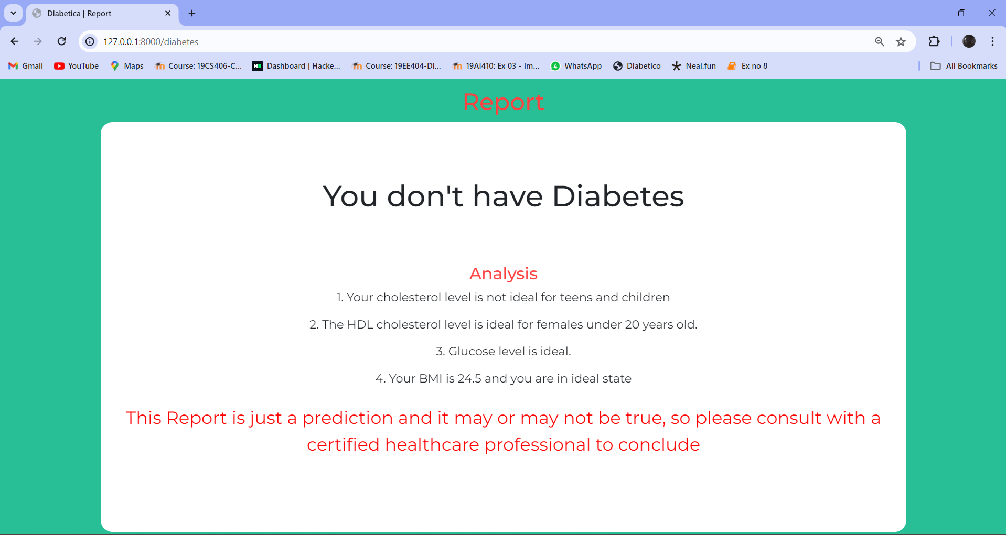

**Fig 5.5 Report Page of User Input**

1. **CONCLUSION**

In the project "Diabetica", a web-based diabetes prediction model using logistic regression is developed. This model aims to predict the likelihood of an individual having diabetes based on various input features. The project involves several key components, including data preprocessing, model development, web application development, and deployment.

The first step in the project is data preprocessing, which involves cleaning and preparing the dataset for training the model. This includes handling missing values, converting categorical variables into numerical representations, and scaling the features to ensure uniformity.

Next, a logistic regression model is trained using the preprocessed dataset. Logistic regression is chosen for its ability to predict binary outcomes, making it suitable for predicting diabetes (either the individual has diabetes or not).

Once the model is trained, a web application is developed to provide a user-friendly interface for users to input their data and obtain a prediction. The web application is designed to be intuitive and easy to use, allowing users to input relevant features such as glucose levels, BMI, age, and other health metrics.

Upon submitting their data, the web application uses the trained logistic regression model to predict the likelihood of the user having diabetes. The prediction is then displayed to the user along with any additional insights or recommendations.

Finally, the web application is deployed to a server to make it accessible to users over the internet. This ensures that individuals can easily access the diabetes prediction tool and make informed decisions about their health.

Overall, the Diabetica project demonstrates the use of logistic regression and web technologies to develop a practical and accessible tool for diabetes prediction, potentially aiding in early detection and management of diabetes.

**REFERENCES**

[1] G Parimala, R Kayalvizhi and S Nithiya, “Diabetes prediction using machine learning”, In: International Conference on Computer Communication and informatics ( ICCCI), 2023.

[2] Md. Faisal Farque, Asaduzzaman, Iqbal H. Sarker, “Machine learning techniques to predict diabetes mellitus”. In: International Conference on Electrical, Computer and communication Engineering ( ECCE) , 2019.

[3] Nahla Barakat, Andrew P. Bradely, Mohammed Nabil H barakat, “Intelligible support vector machines for diagnosis of diabetes mellitus”. In: IEEE Transactions on Information Technology in Biomedicine, 2012.

[4] Pragya Paudyal PhD, “Diabetes prediction using logistic regression in python”. In: Medium.com, 2020.

[5] Zarinabegam Mundargi, Mayur Dabade, Yash Chindhe, Savani Bondre, Anannya Chaudhary, “Diabetes prediction using Logistic Regression”. In: Renewable Energy, Green Computing and Sustainable Development, 2024.

[6] Roshi Saxena, Sanjay Kumar Sharma, Manali Gupta and G. C. Sampada, “A Comprehensive review of various diabetic prediction models”, In: Journal of Health care Engineering, 2022.

[7] Anushka Awasthi, Ishwar Gangwal, Mihir Jain, “Diabetes Prediction using Machine Learning: A Review”. In: IJRASET Journal for Research in Applied Science and Engineering Technology, 2022.

[8]Turki Alghamdi, “Prediction of Diabetes Complications Using Computational Intelligence Techniques”. In: Computation and Complex Data Processing Systems, 2023.

[9]Mohammed Mustafa, “Diabetes prediction dataset”, In: Kaggle,2023.

[10] M. Ramakrishna Murthy, P. Ruchita, Ch. Bharat Teja, M. Manoj Kumar, T V S Lingeswararao. “Diabetes prediction using machine learning algorithms”. In: International Research Journal of Modernization in Engineering Technology and Science ,2022.